**English Academic Writing: Unit 1 Academic Writing Style**

WU Ting 语通未来

Hello, everyone！From today, we will be posting a serial of wechat mini-lessons here to help you review our course.

Let's begin with Unit one:  Academic Writing Style

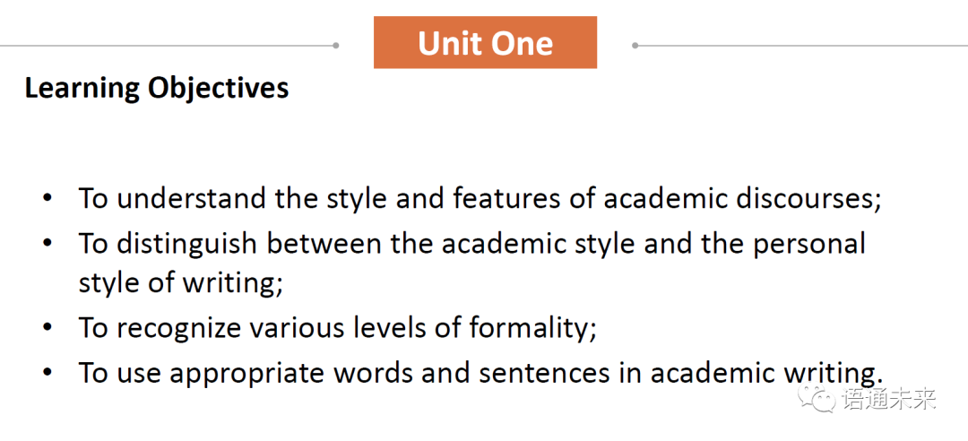

First, you need to consider the following *questions*:

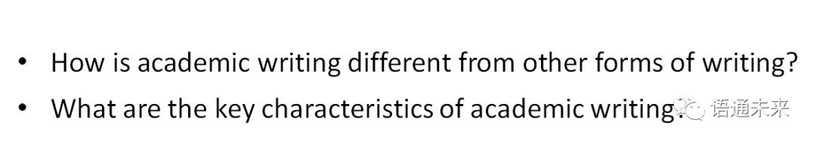

*Ideas for reference:*

Generally speaking, academic writing:

  • is more objective;

  • is more complex;

  • has a more formal structure;

  • uses more referencing.

Then,  look at  some specific rules at various language levels.

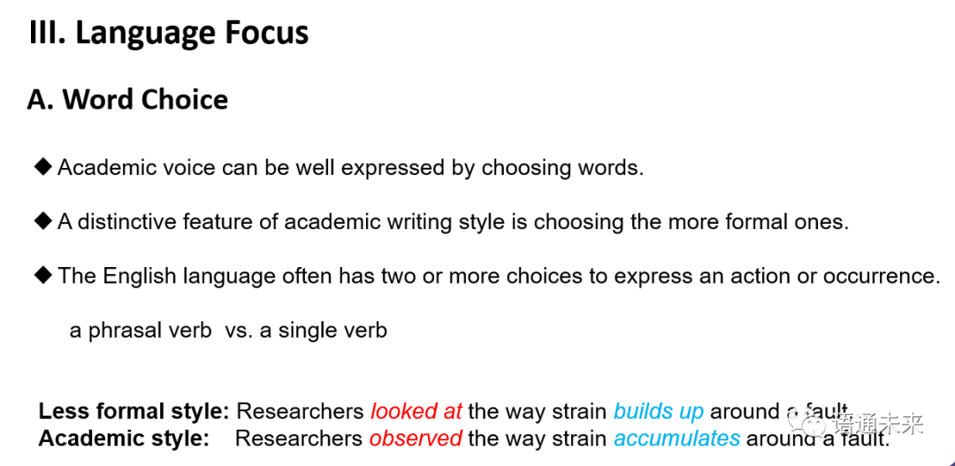

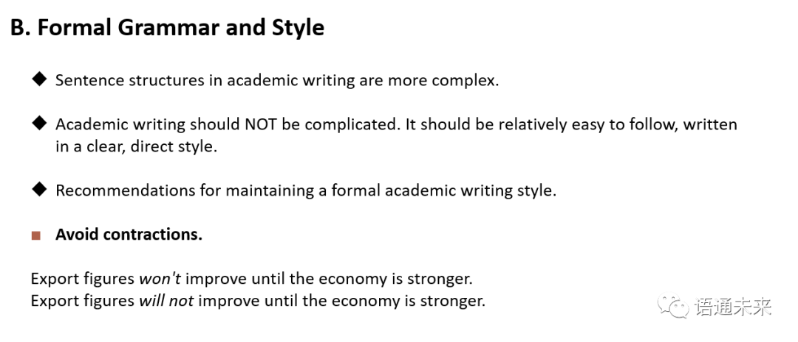

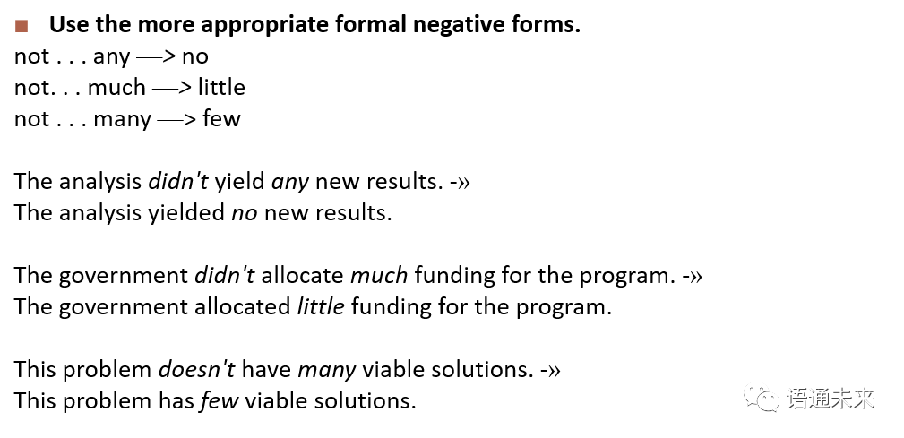

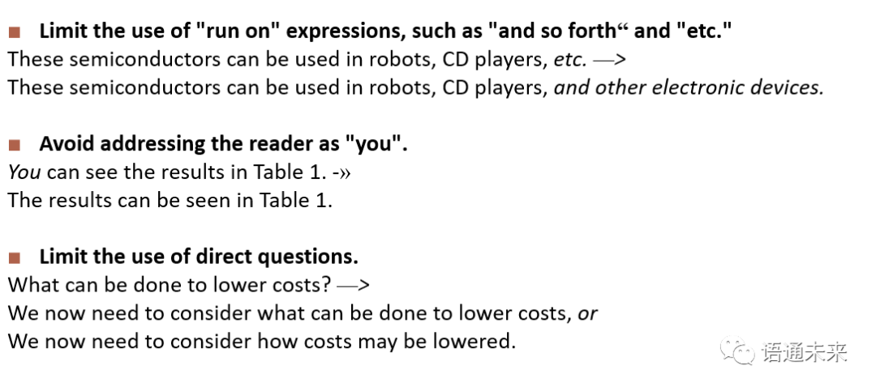

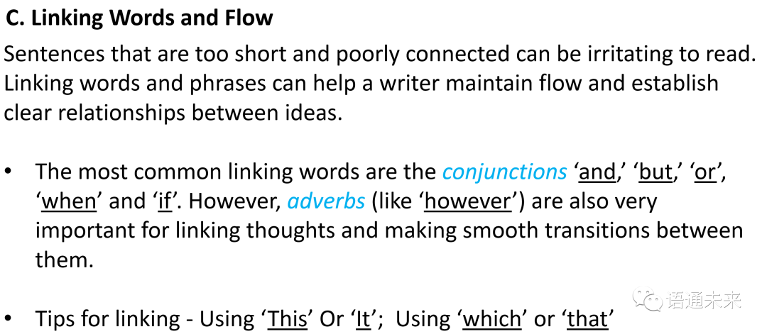

Finally, you need to enhance your writing skills by getting familiar with different styles and be able to convert  the texts from one style to another.

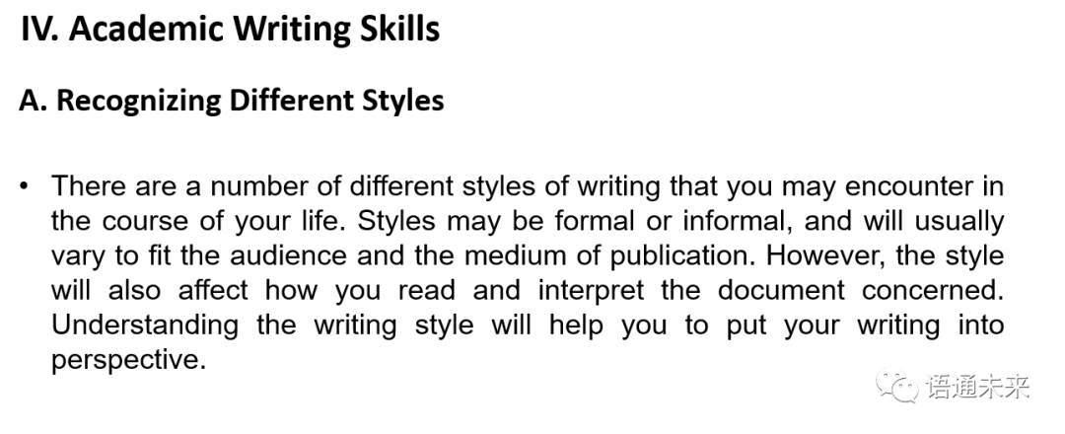

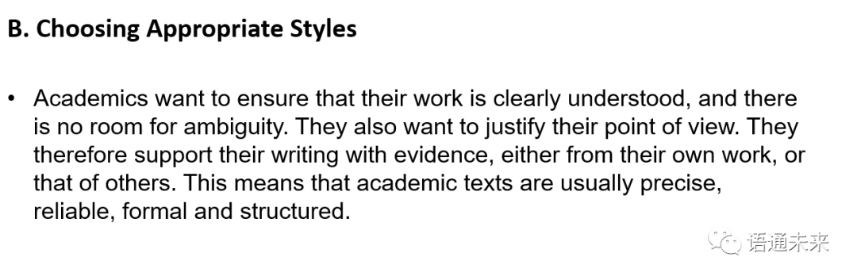

These rules of academic writing are made through years of research by seasoned scholars, which may influence and define us, but they do not need to crush and confine us.

The author of *Scientific Writing = Thinking in Words* has great news: “If you are precise, clear and brief, then you do not have to conform to any other specific rules to be a good scientific writer.”

Good luck with your paper writing!

## English Academic Writing: Unit 2 Research Proposal

李黎 语通未来

**Unit 2 Research Proposal**

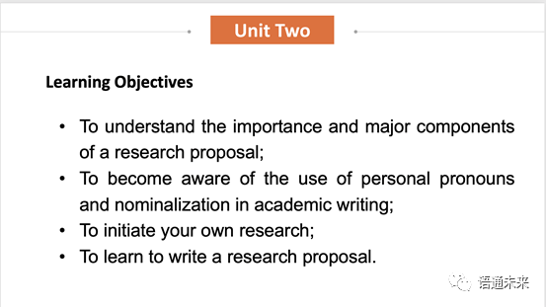

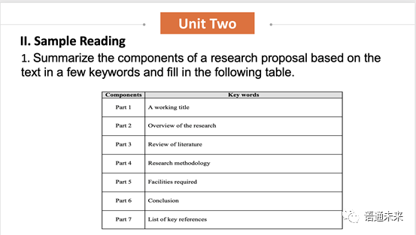

The following key to the question is forreference.

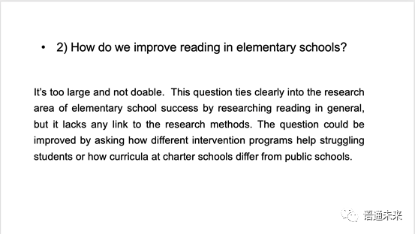

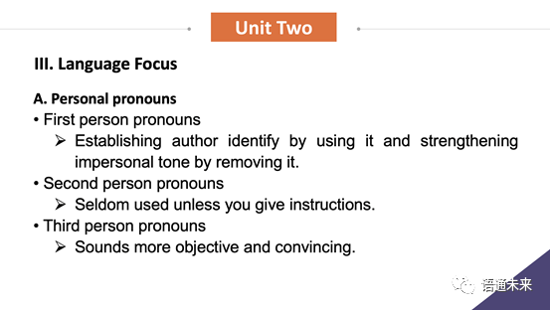

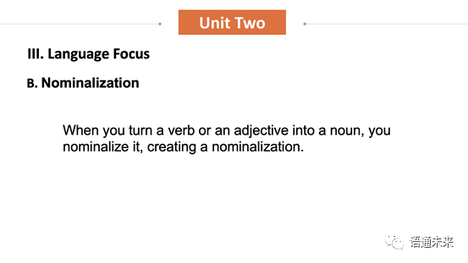

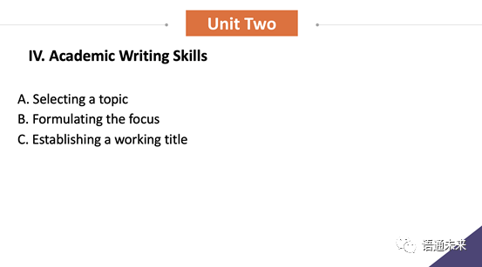

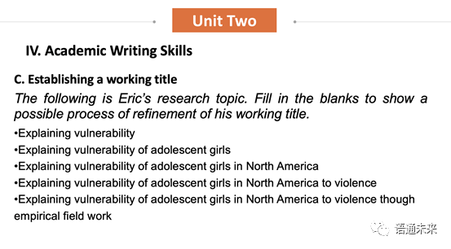

**English Academic Writing: Unit 3 Introduction&Literature Review**

**孙书兰 语通未来**

**Unit 3**

**Learning Objective**

* To understand general functions of the introduction section;
* To learn how to cite other people’s previous work;
* To get familiar with the writing of a literature review;
* To learn how to avoid plagiarism by paraphrasing.

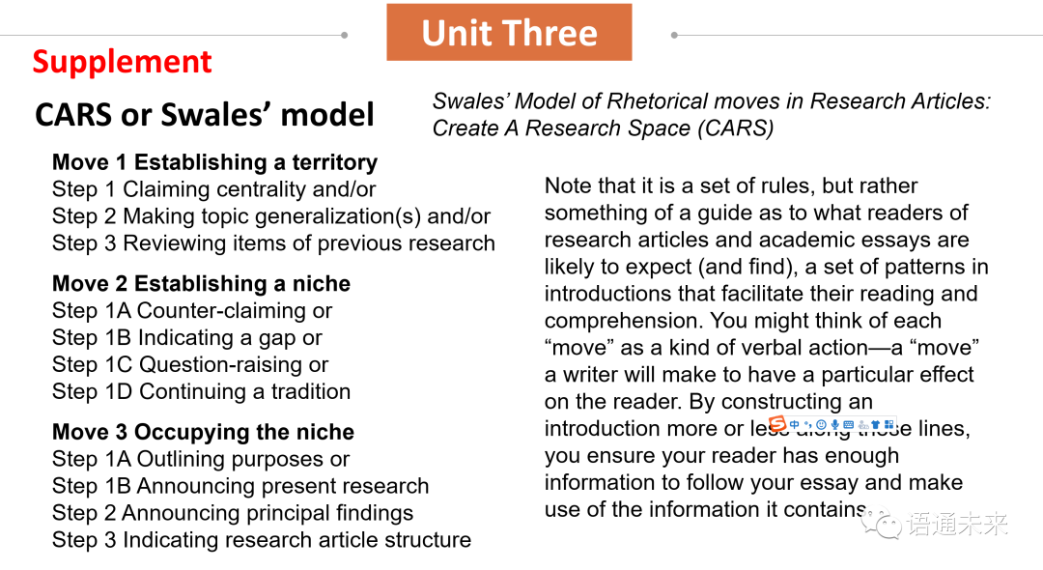

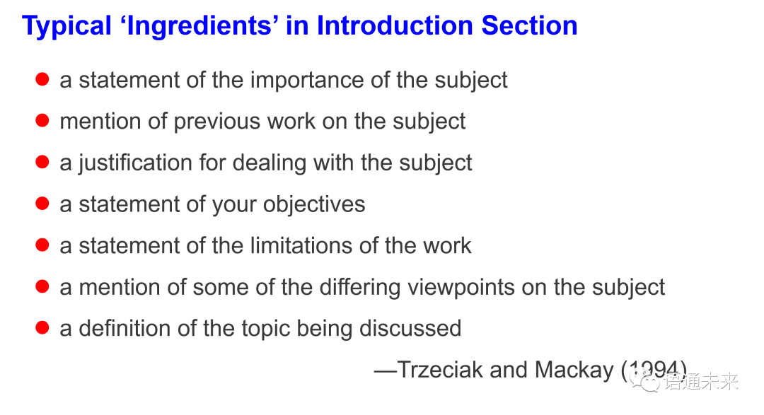

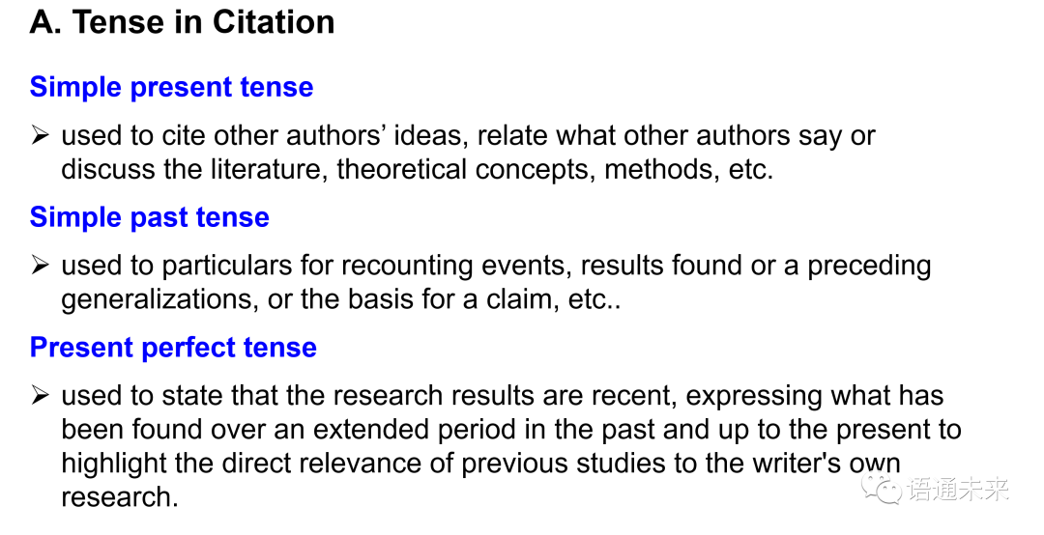

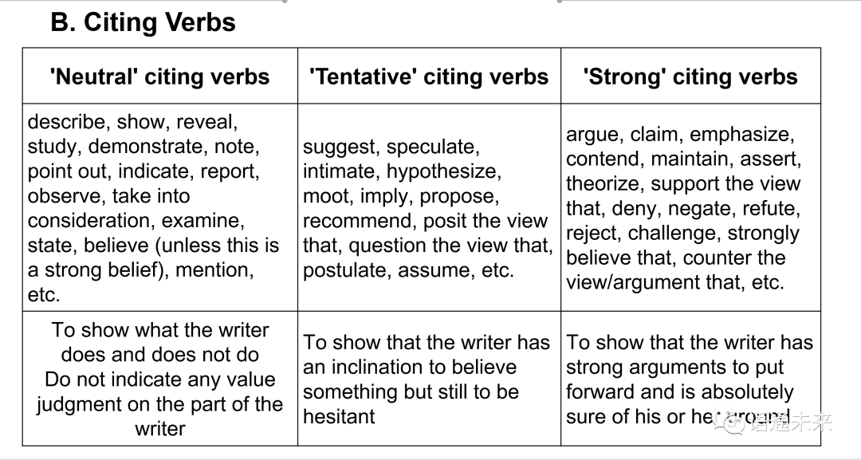

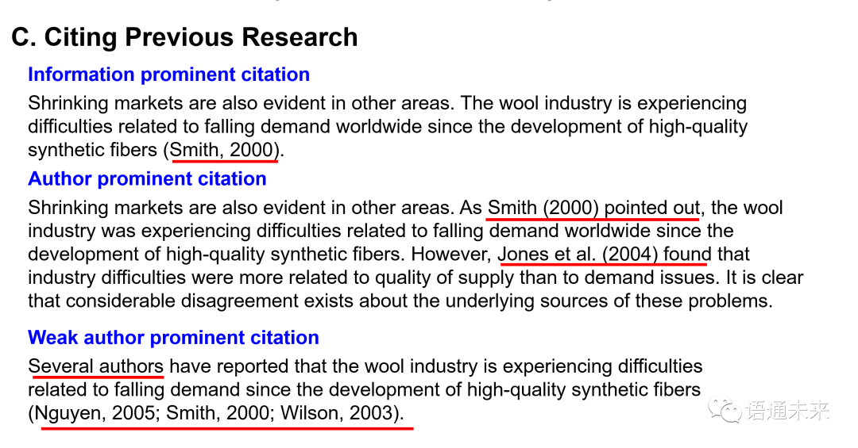

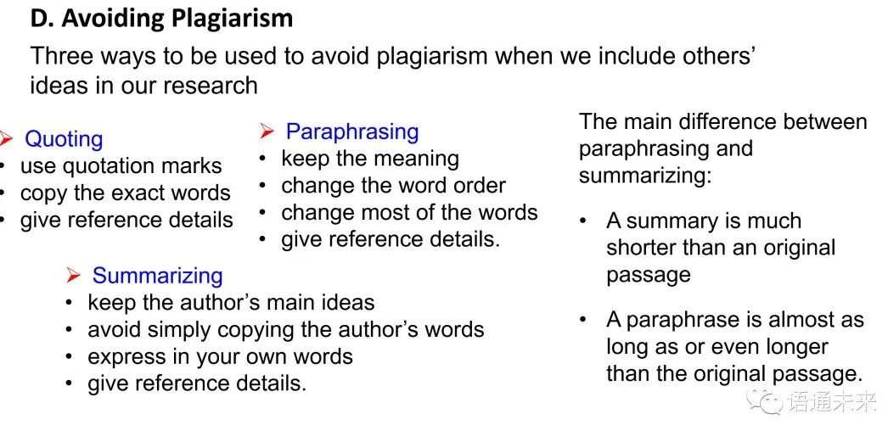

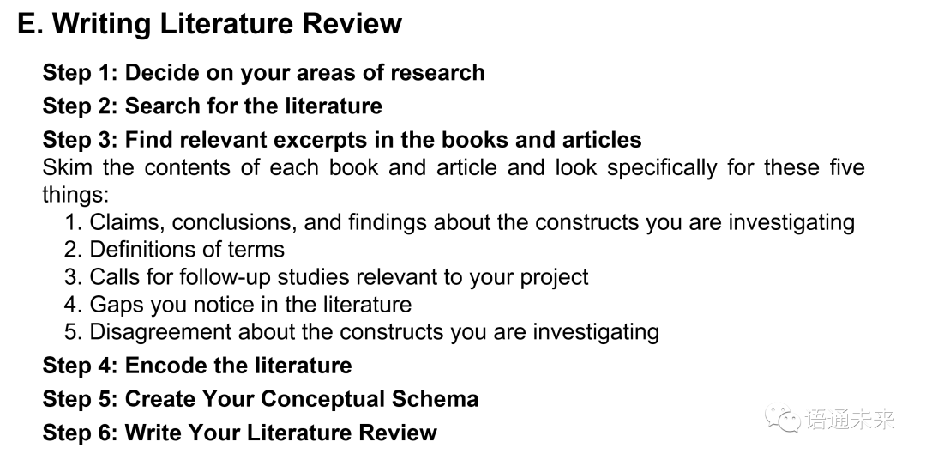

## English Academic Writing: Unit 4 Methodology Description

吕琴 语通未来

**Sequential Markers**

The following sequencing expressions are more frequently used to link steps in a description of a process or to divide a process into steps:

     • To begin with...,  First of all... etc.;

     • Secondly...,  Next..., After that...,  In addition...etc.;

     • Finally...,  Lastly... etc.

***Additional: Initially, subsequently, synchronize, simultaneously***

 2. Normally, a method section includes the following information elements:

• **Overview of the research**: brief description about what has been done;

• **Subjects**: the people/subjects studied, or the things tested;

• **Location**: where a research takes place;

• **Restrictions/Limitingconditions**: precautions taken to make sure that the data is valid;

• **Sampling techniques**: describing how the subjects are selected for research;

• **Materials**: the materials used to conduct a study or an experiment;

• **Procedure**: the steps of conducting the research in a chronological order;

• **Statistical treatment**: describing how the statistics are examined.

Of all the information elements in this list, the only items that are always included in the method section are **materials** and **procedure**.

**3. Ordering Methodology Elements**

      Research methodology is mainly about the procedures by which researchers go about their work of describing, explaining, and predicting phenomena. You need to state the purpose of the study and define the problem /issue clearly.

    This guides you in deciding the methodology of research which involves:

      • identifying the method of research;

      • specifying the subjects of study;

      • selecting an adequate representative sample of subjects;

   • selecting reliable instruments for measuring the variables in a research problem;

   • describing the procedure to be employed for conducting your research;

      • collecting data;

      • analyzing and interpreting your results.

## English Academic Writing: Unit 5 Results&Discussion

陈峥嵘 语通未来

English Academic Writing: Unit 5 Results&Discussion

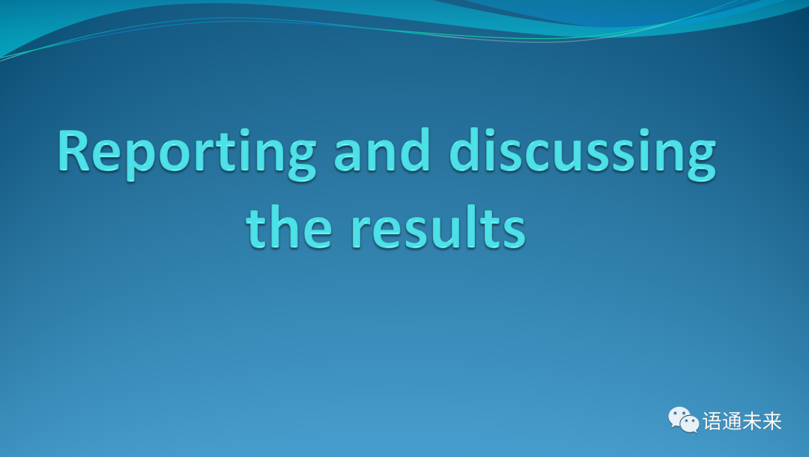

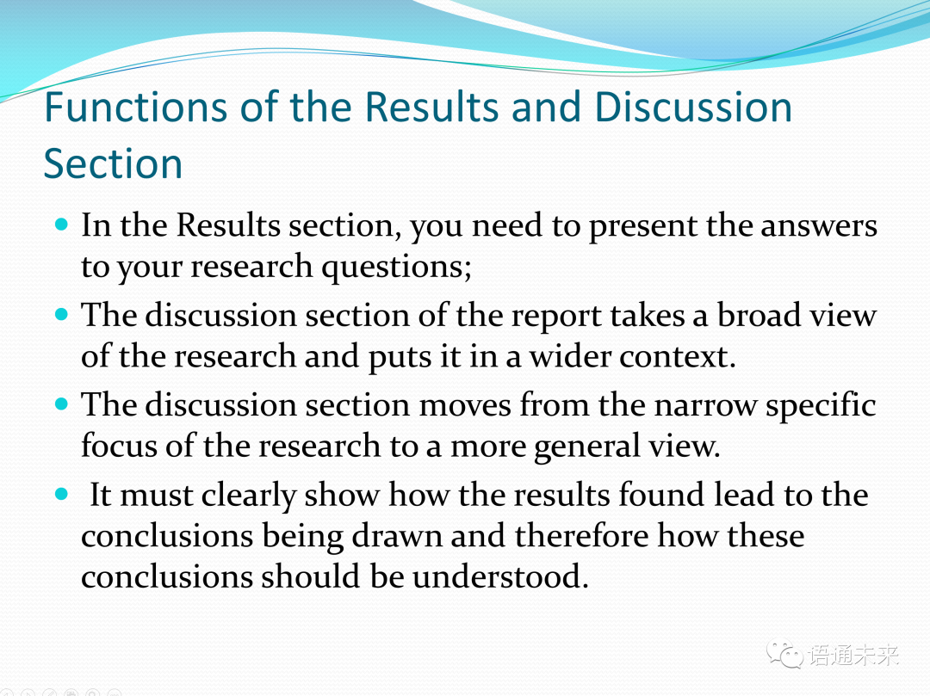

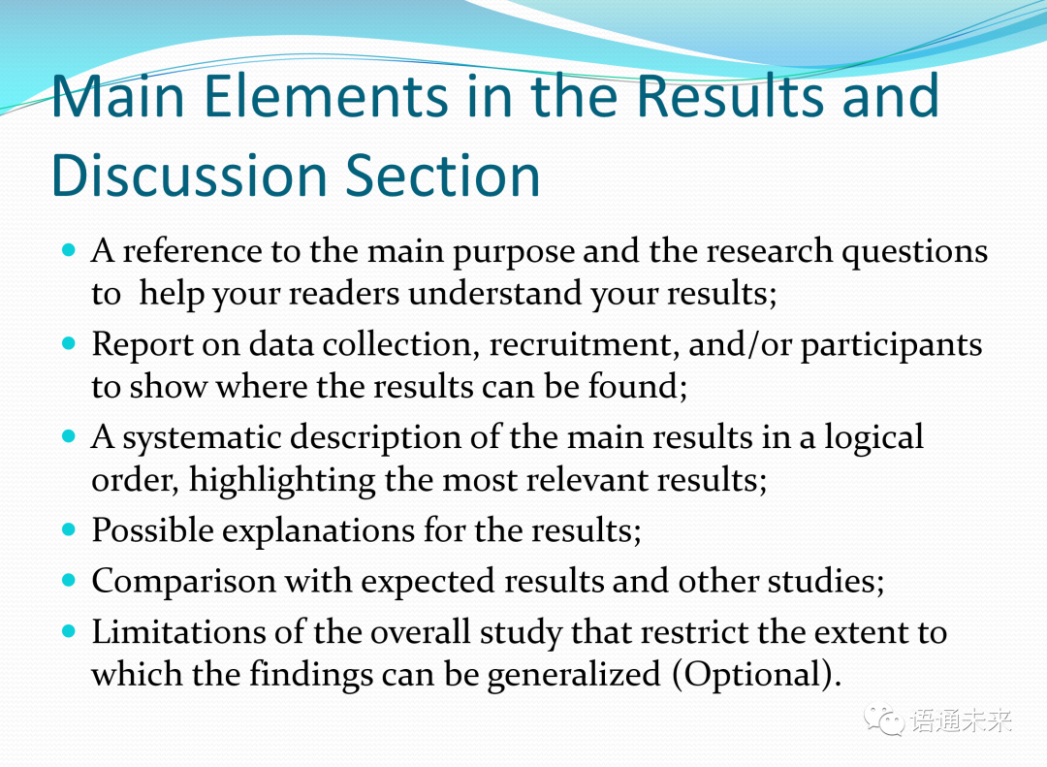

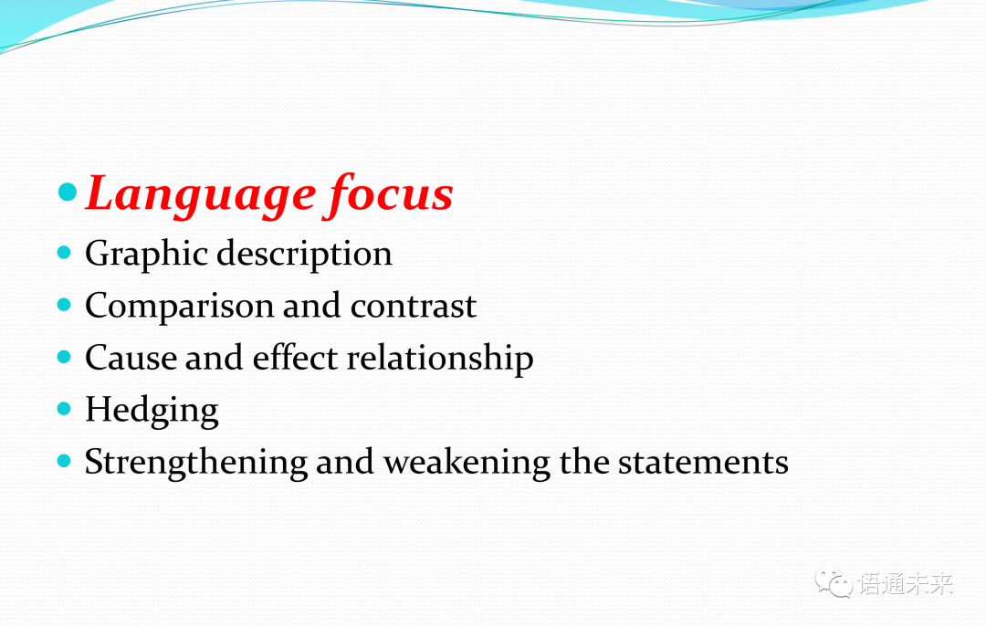

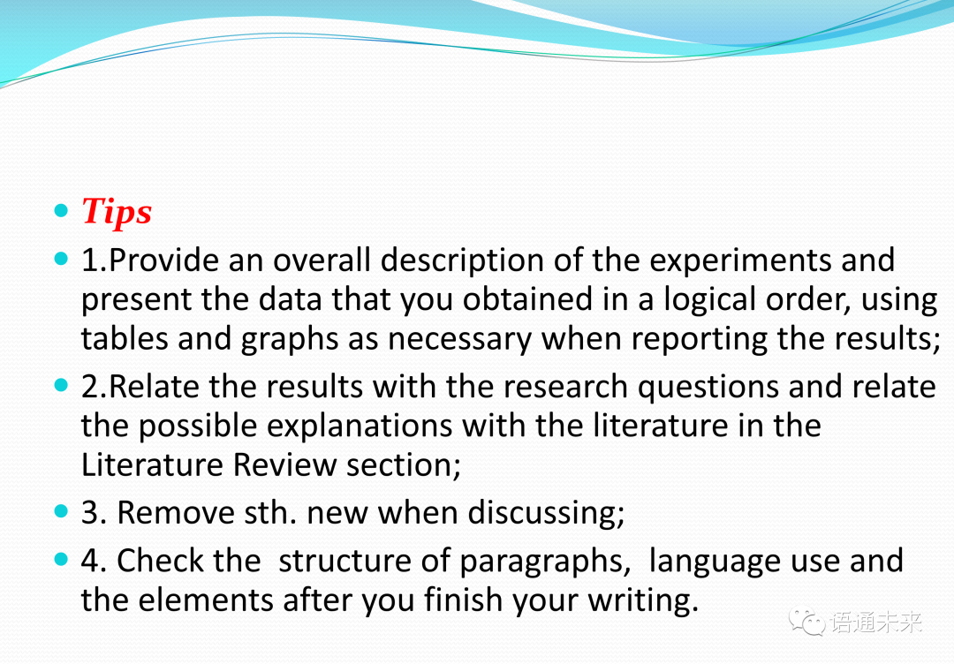

## English Academic Writing: Unit 6 Research Conclusion

蔡旭东 语通未来

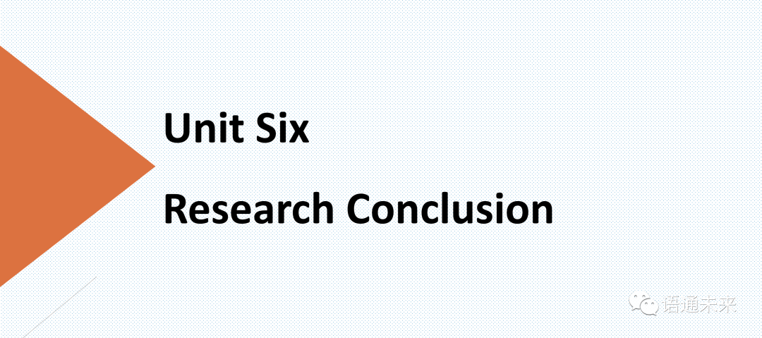

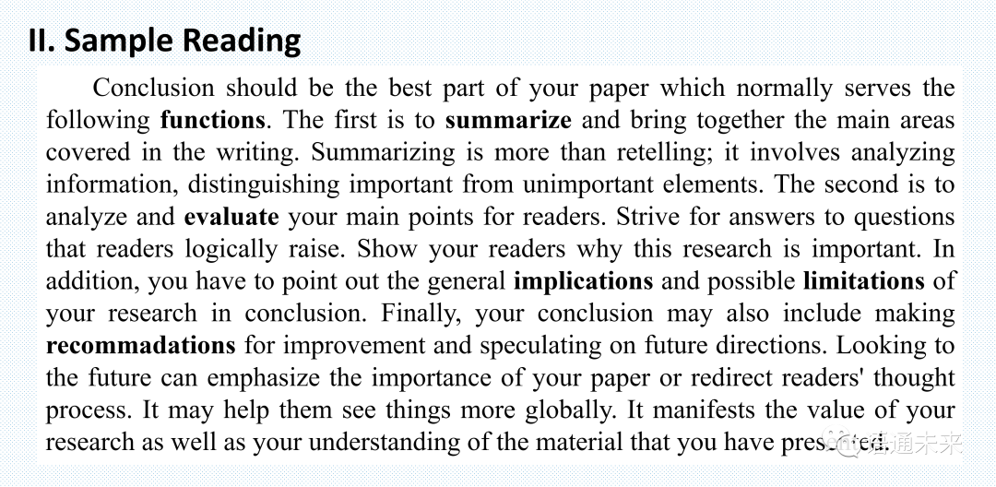

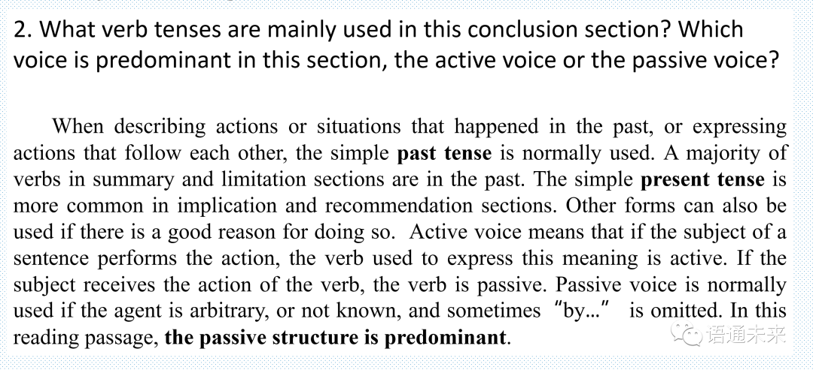

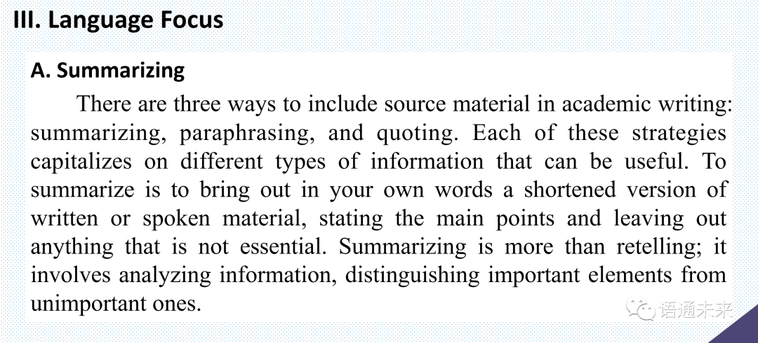

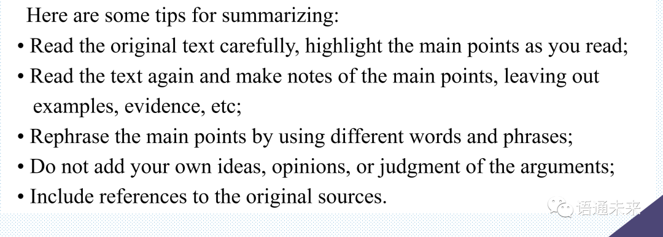

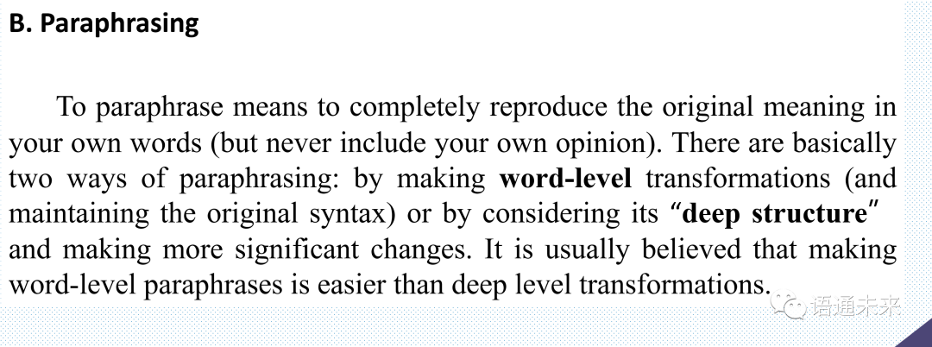

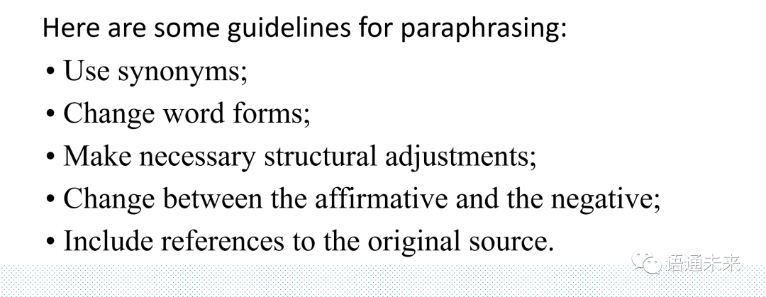

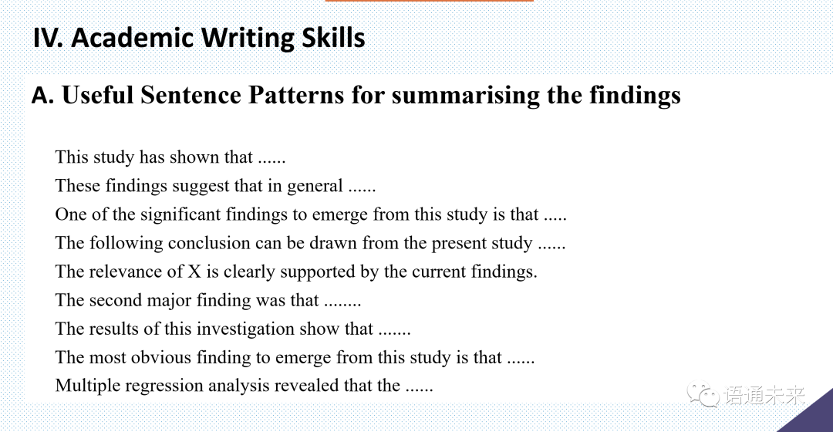

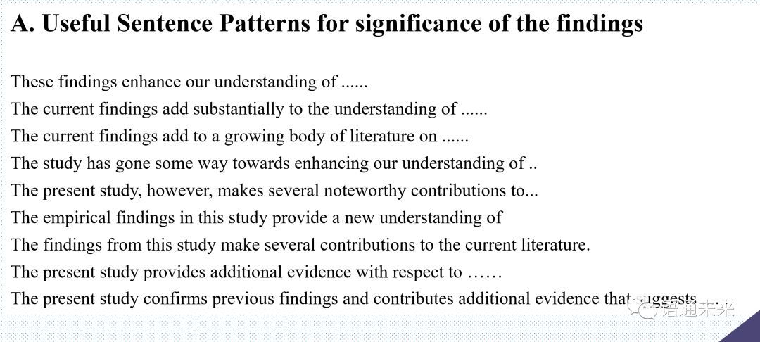

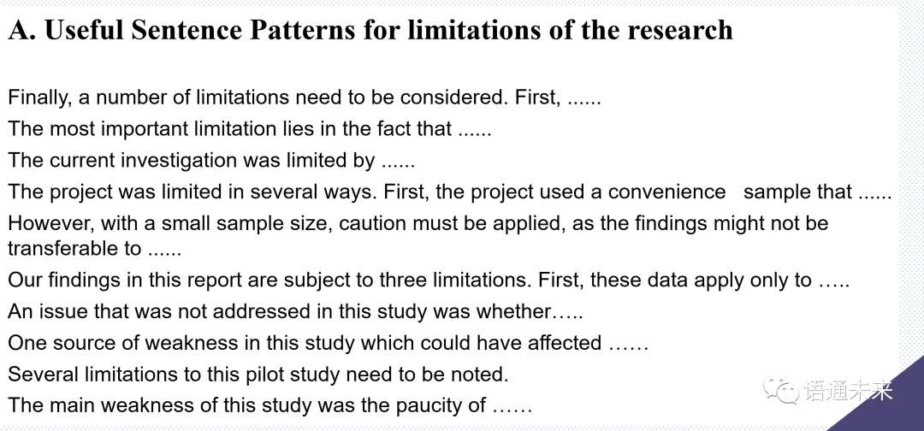

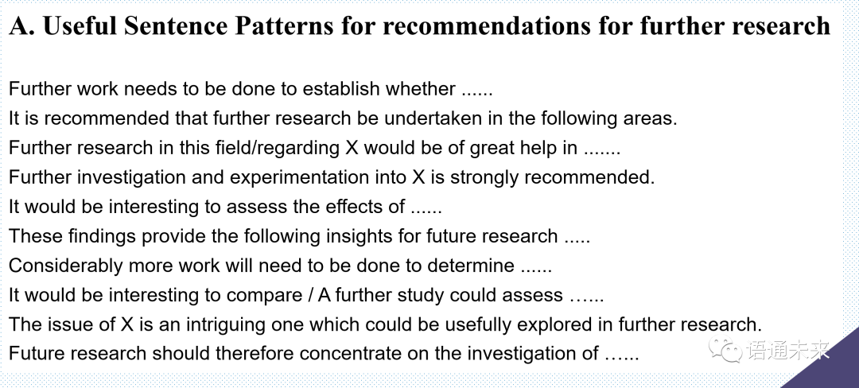

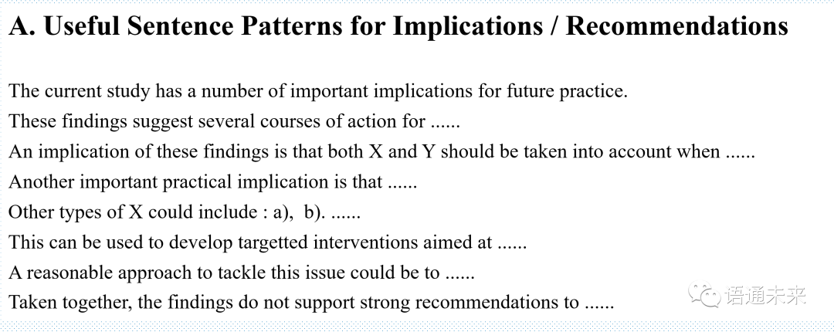

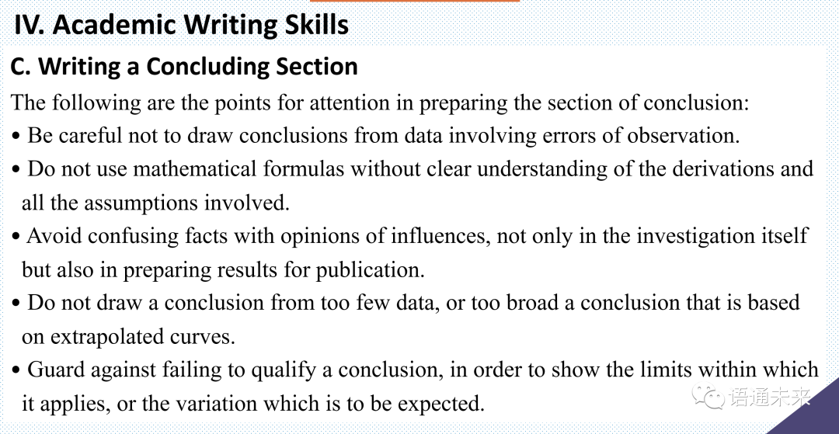

## English Academic Writing: Unit 7 Abstract&Documentation

凌建辉 语通未来

English Academic Writing: Unit 7 Abstract & Documentation

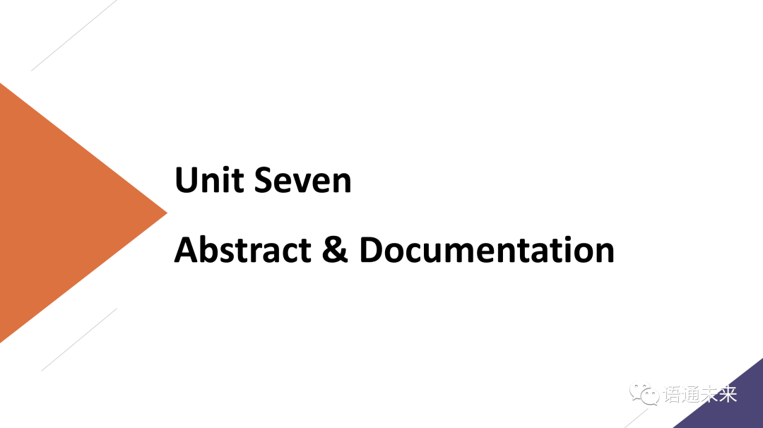

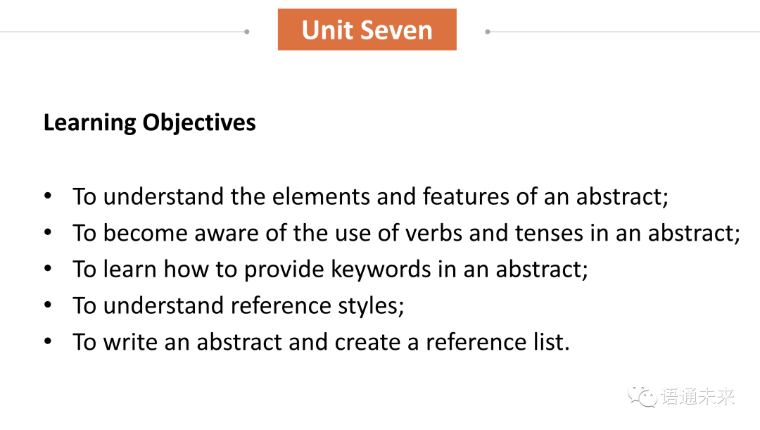

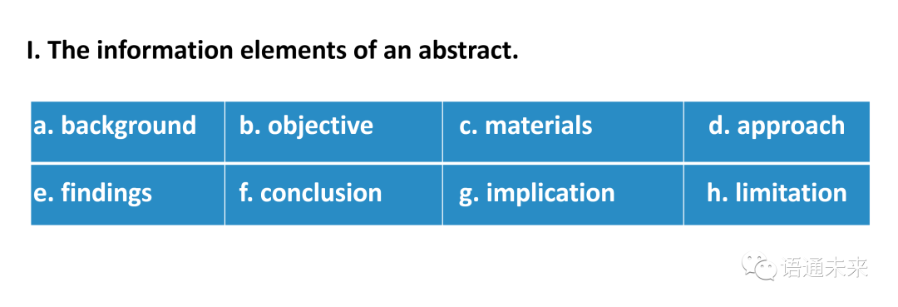

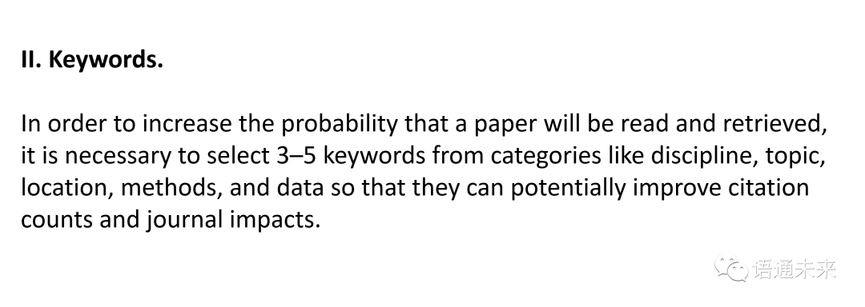

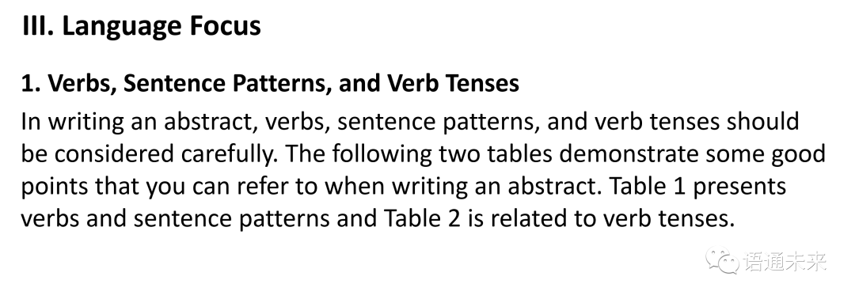

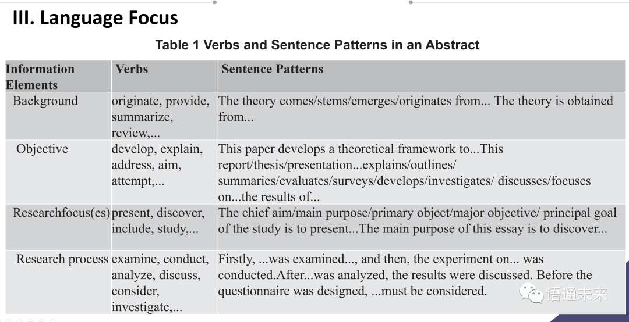

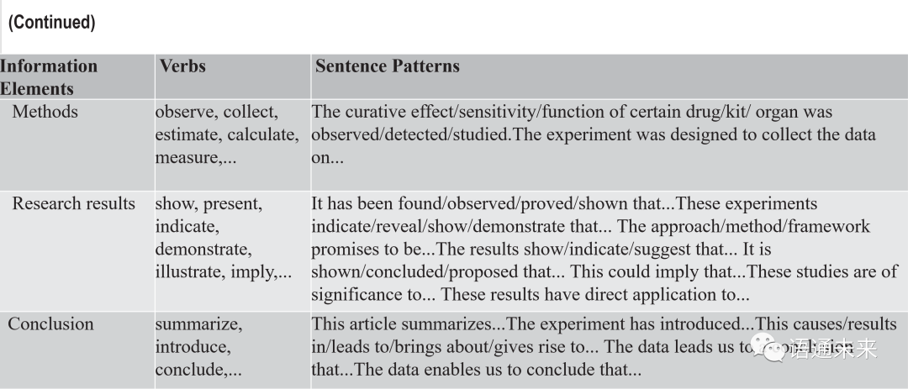

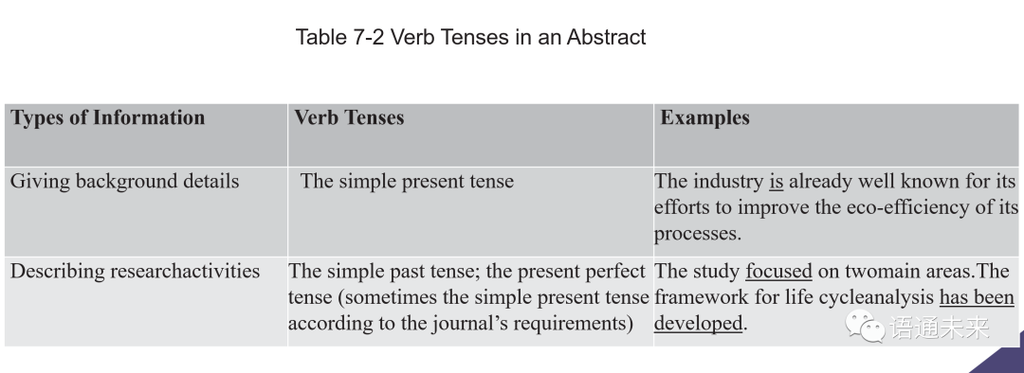

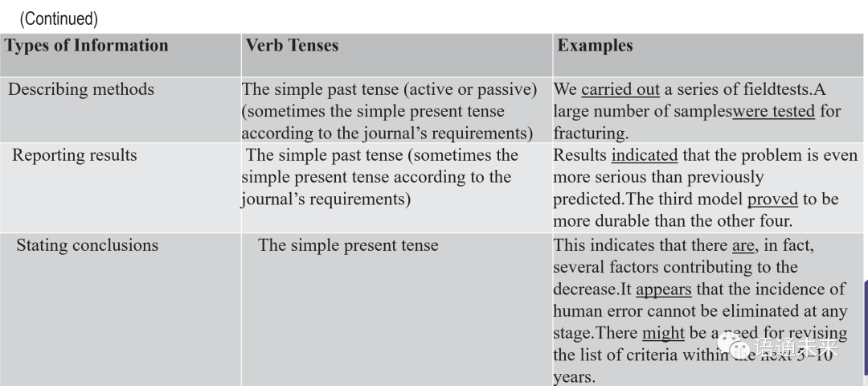

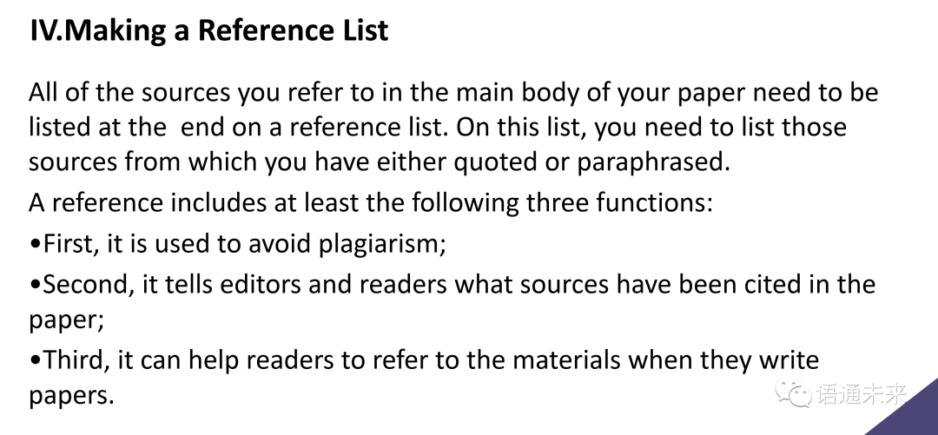

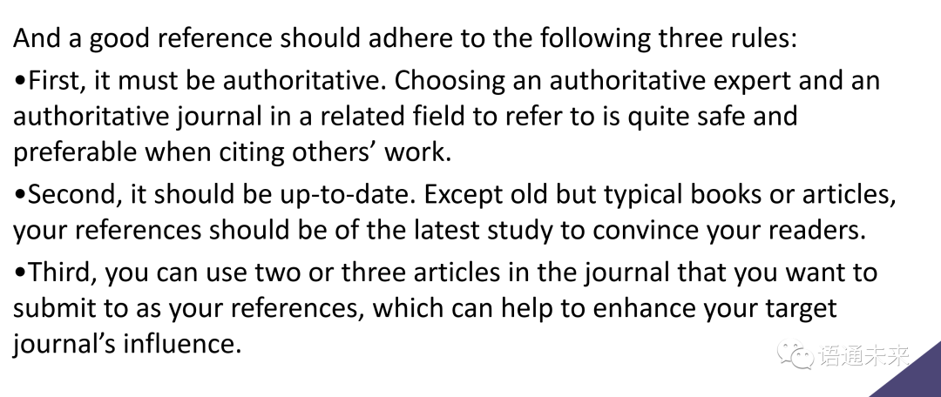

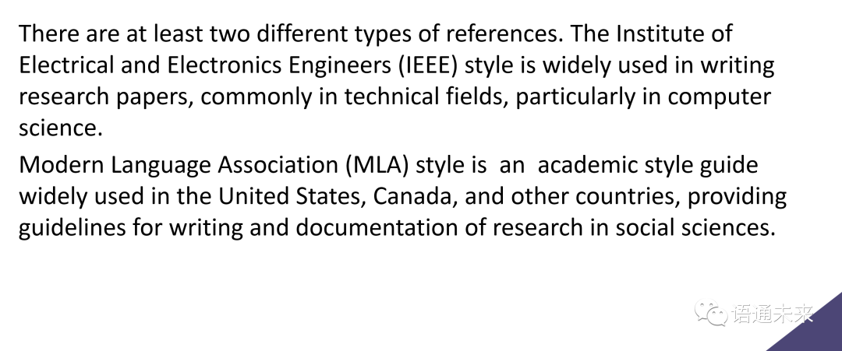

## English Academic Writing: Unit 8 Acknowledgements&submission

李黎 语通未来

Unit 8 Acknowledgements and submission

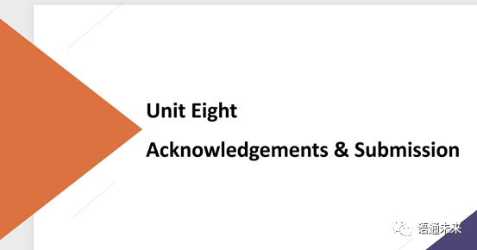

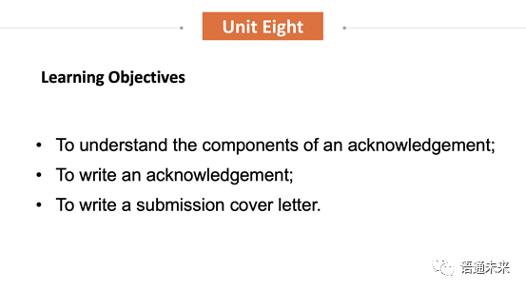

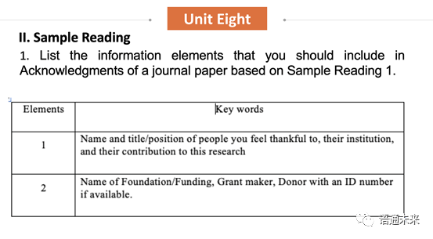

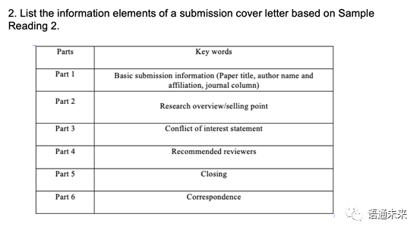

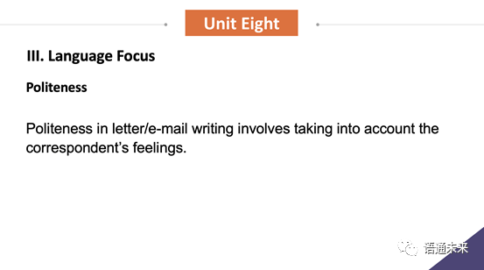

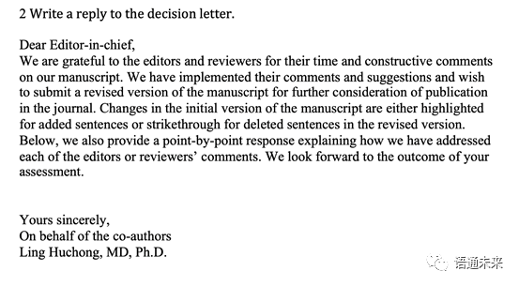

## English Academic Writing: Unit 8 Acknowledgements&submission

俞韫烨 语通未来

